Lyle Collodi model refs
Azure artwork

–
(ELF) Artwork | Icon | Model refs | Weapon
(Valkyrie) Artwork | icon | model refs | outfit icon

–
Honky News Network

EX:
ELF | Artwork | Icon | Model Refs | Weapon
 | 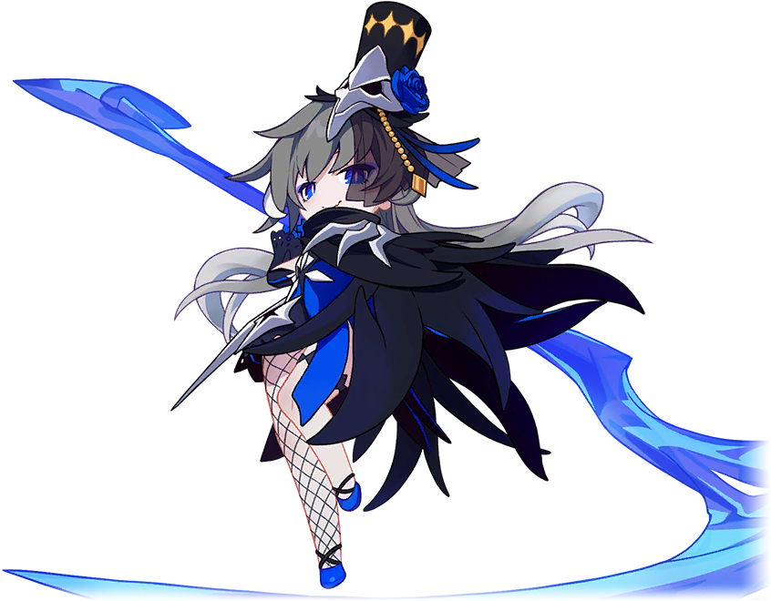 |  | 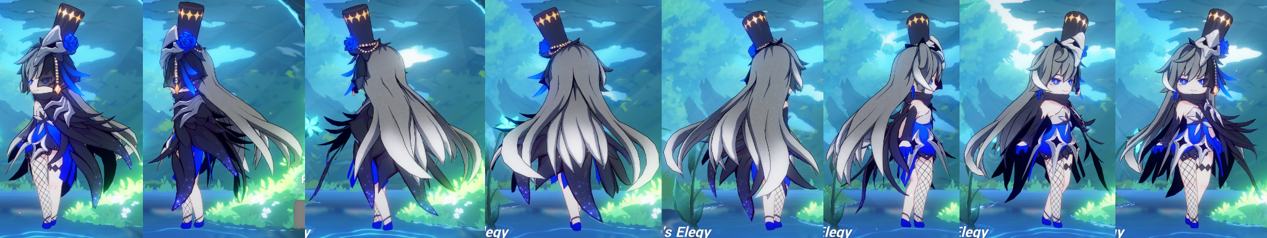 | 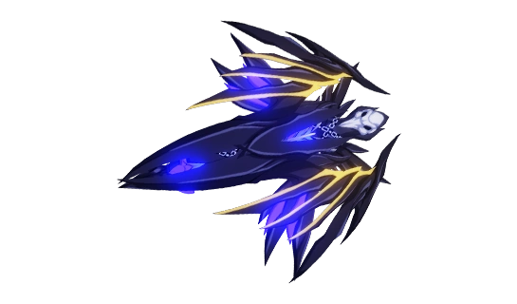
Valkyrie | Artwork | Icon | Model Refs | Outfit Icon
 | 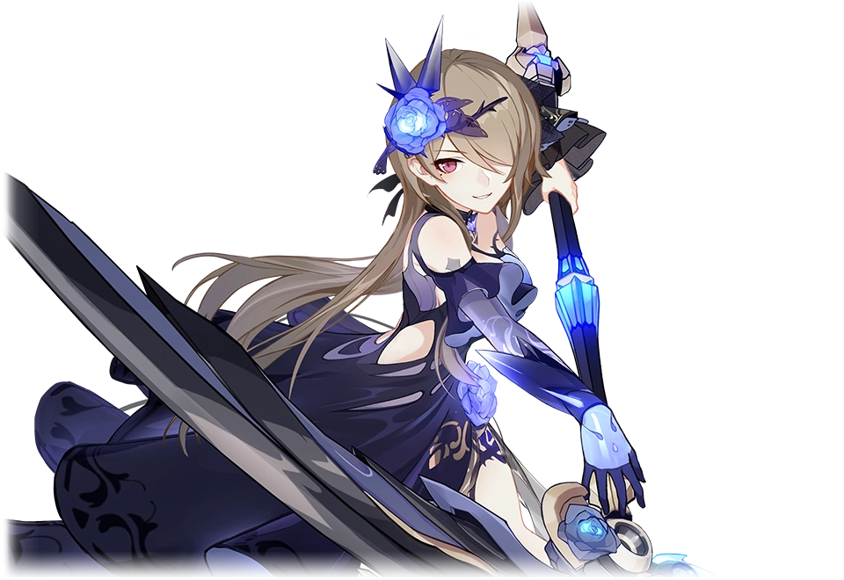 |  | 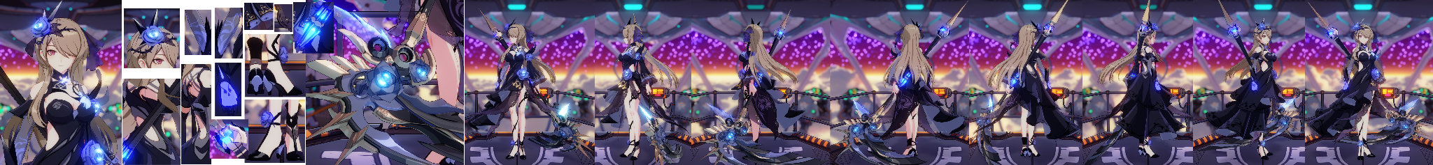 | 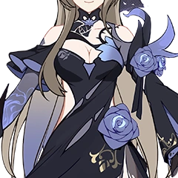

Model refs (Remake)  *NO GUARANTEE I’LL HAVE ACCESS TO ALL OF THESE / WAITING FOR RELEASE | Official models for these costumes are fan made and won’t have refs until they’re updated
Mesmerizing Blue (Aponia)  Black Nucleus (Bronya)  Candy Demon (Bronya)  Dimension Breaker (Bronya)  White Devil (Bronya)  Drive Kometa (Bronya)  Fleurs du Mal (Bronya)  Haxxor Bunny (Bronya)  Neonized (Bronya)  Herrscher of Reason (Bronya)  MAGIC GIRL BRONYA (Bronya)  Mercurial Hatter (Bronya)  Nightfall Witch (Bronya)  Old Times (Bronya)  School Swimsuit (Bronya)  SILVERWING N-EX (Bronya)  Snowy Sniper (Bronya)  Carrot & Beet Soup (Bronya)  Summer Night’s Dream (Bronya)  Valkyrie Chariot (Bronya)  Blue Sky (Bronya)  Wolf’s Dawn (Bronya)  Midnight Blues (Bronya)  Yamabuki Armor (Bronya)  Helena’s Wings (Bronya)  Throatwort (Bronya)  Carole Pepper  Blade Durandal  Bright Knight Excelsis (Durandal)  Dea Anchora (Durandal)  Emerald of Alfheim (Durandal)  Lord Paramount (Durandal)  Nibelungen Traumlied (Durandal)  Palatinus Equinox (Durandal)  Stellar Promise (Durandal)  Valkyrie Gloria (Durandal)  Misty Lavender (Durandal)  Flowing Rhyme (Eden)  Faded Miss Elf (Elysia)  Miss Pink (Elysia)  Tesla x Evangelion (Tesla)  Tesla Stan Wars (Tesla)  Tesla ZERO  Azure Empyrea (Fu Hua)  Blood Voivode (Fu Hua)  Blue Swallow (Fu Hua)  Cerulean Court (Fu Hua)  Hawk of the Fog (Fu Hua)  Night Squire (Fu Hua)  Dark Butler (Fu Hua)  Ooh Summer (Fu Hua)  Phoenix (Fu Hua)  Rustic Noir (Fu Hua)  Seagull’s Soar (Fu Hua)  Shadow Knight (Fu Hua)  Spring Traveler (Fu Hua)  Sword and Fire (Fu Hua)  Turn Up the Music (Fu Hua)  Book of Fuxi (Fuxi/Nuwa)  Maroon Riding Hood (Griseo)  Starry Impression (Griseo)  Jackal  Ji Xuanyuan  Jingwei’s Wings  Hanami Daimyo (Kallen)  Sixth Serenade (Kallen)  Sundenjager (Kallen)  Bastet’s Secret (Kiana)  Frigid Empress (Kiana)  Frostmoon Bunny (Kiana)  Herrscher of the Void (Kiana)  Houkai World Diva (Kiana)  Knight Moonbeam (Kiana)  Dark Devourer (Kiana)  Lemon Soda (Kiana)  Magic Girl Sirin (Kiana)  Parasol Kaiserin (Kiana)  Prodigal Girl (Kiana)  White Comet (Kiana)  Starless Rift (Kiana)  Sea & Breeze (Kiana)  Time Runner (Kiana)  Valkyrie Ranger (Kiana)  Ocean Ranger (Kiana)  Void Drifter (Kiana)  Red Lictor / Radiant Blaze (Kiana)  Winter Princess (Kiana)  Klein  Auspicious Dazzle (Sushang)  Einstein  Blueberry Blitz (Liliya)  Shelly’s Beastliya (Liliya)  Wave Galactica (Liliya)  Lyle Collodi  Daughter of Corals (Mobius)  Scorching Gravel (Mobius)  Blood Rose / (+purple version??) (Himeko)  Kriegsmesser (Himeko)  Rosy Passion (Himeko)  Valkyrie Triumph (Himeko)  Vermilion Knight Eclipse (Himeko)  Spectral Raven (Raven)  Otto Apocalypse  Midsummer Collector (Pardofelis)  Simply Orange (Pardofelis)  Spectral Claws (Pardofelis)  Aeterna Purum (Mei)  Aqueous Springtide (Mei)  Crimson Impulse (Mei)  Azure (Mei)  Gardenia (Mei)  Eventide Phantom (Mei)  Haunted Dusk (Mei)  Nocturne Ablaze (Mei)  Orochi Cuirass (Mei)  Shadow Dash (Mei)  Soul Symphony (Mei)  Striker Fulminata (Mei)  Thunderbolt Drive (Mei)  Ultramarine Octave (Mei)  Valkyrie Bladestrike (Mei)  Blue Memories (Mei)  Argent Knight Artemis (Rita)  Dame de Coeur (Rita)  Dusky Murmurs (Rita)  Eternal Dance (Rita)  Fallen Rosemary (Rita)  Icy Sea Spray (Rita)  Summer Night’s Dream (Rita)  Maid of Celestia (Rita)  Phantom Iron (Rita)  Spina Astera (Rita)  Umbral Rose (Rita)  Victoria (Rita)  VALKYRIE DAWN (Rita)  Vow of Roses (Rita)  Coral Sunrise (Rozaliya)  Fervent Tempo Delta (Rozaliya)  Gothic Rozamary (Rozaliya)  Molotov Cherry (Rozaliya)  Violet Dreamscape (Rozaliya)  Azure Memories (Seele + Veliona)  Dream Seeker (Seele + Veliona)  Estonia in Spring (Seele + Veliona)  Mirrored Flourishes (Seele + Veliona)  Papilio Lily (Seele + Veliona)  Stygian Nymph (Seele + Veliona)  Stygian Seafoam (Seele + Veliona)  Swallowtail Phantasm (Seele + Veliona)  Selune’s Elegy  Su  Bear Squad Go (Susannah)  Campus Detective (Theresa)  Celestial Hymn (Theresa)  Starry Night (Theresa)  Empyrean Psalms (Theresa)  Magical Teriri (Theresa)  Orchid’s Night (Theresa)  Rosy Bridesmaid (Theresa)  Sakuno Rondo (Theresa)  Starlit Astrologos (Theresa)  Twilight Paladin (Theresa)  Valkyrie Pledge (Theresa)  Verdant Sky (Theresa)  Wonderland Trek (Theresa)  I’m the Storm (Vill-V)  Void Archives  Water’s Edge  Wendy  Blooming Maiko (Yae)  Darkbolt Jonin (Yae)  Shiden Kasumi (Yae)  Dream Raiment (Yae)  Goushinnso Memento (Yae)  Gyakushinn Miko (Yae)  Frozen Sakura (Yae)  Midnight Marigold (Yae)  Hyoukai Sonata (Yae)  Peach Sanctuary (Yae)  Sakura Summer (Yae)  Summer Sakura (Yae) | -Azure Empyrea  -Peach Sanctuary  -Water’s Edge  -Mirrored Flourishes  -DEA Raison (Herrscher of Reason)

